# Opencart Application

OpenCart makes it easy to handle products, categories, customers, and orders with its user-friendly interface, creating a smooth online shopping experience. It supports different ways to pay and ship, ensuring a complete solution for online businesses. The goal of the e-commerce project is to build a safe and user-friendly online store.

Using OpenCart, the website will have important features like user sign-up, a list of products, a shopping cart, secure checkout, online payment options, and efficient order management. This helps customers have a reliable and easy shopping experience.

### **Login**

**User Stories**

As a new user, I want to be able to create a new account and login to the platform.

As an existing user, I want to be able to easily access my account by entering my login credentials.

**Design Mockups**

Login page design mockup

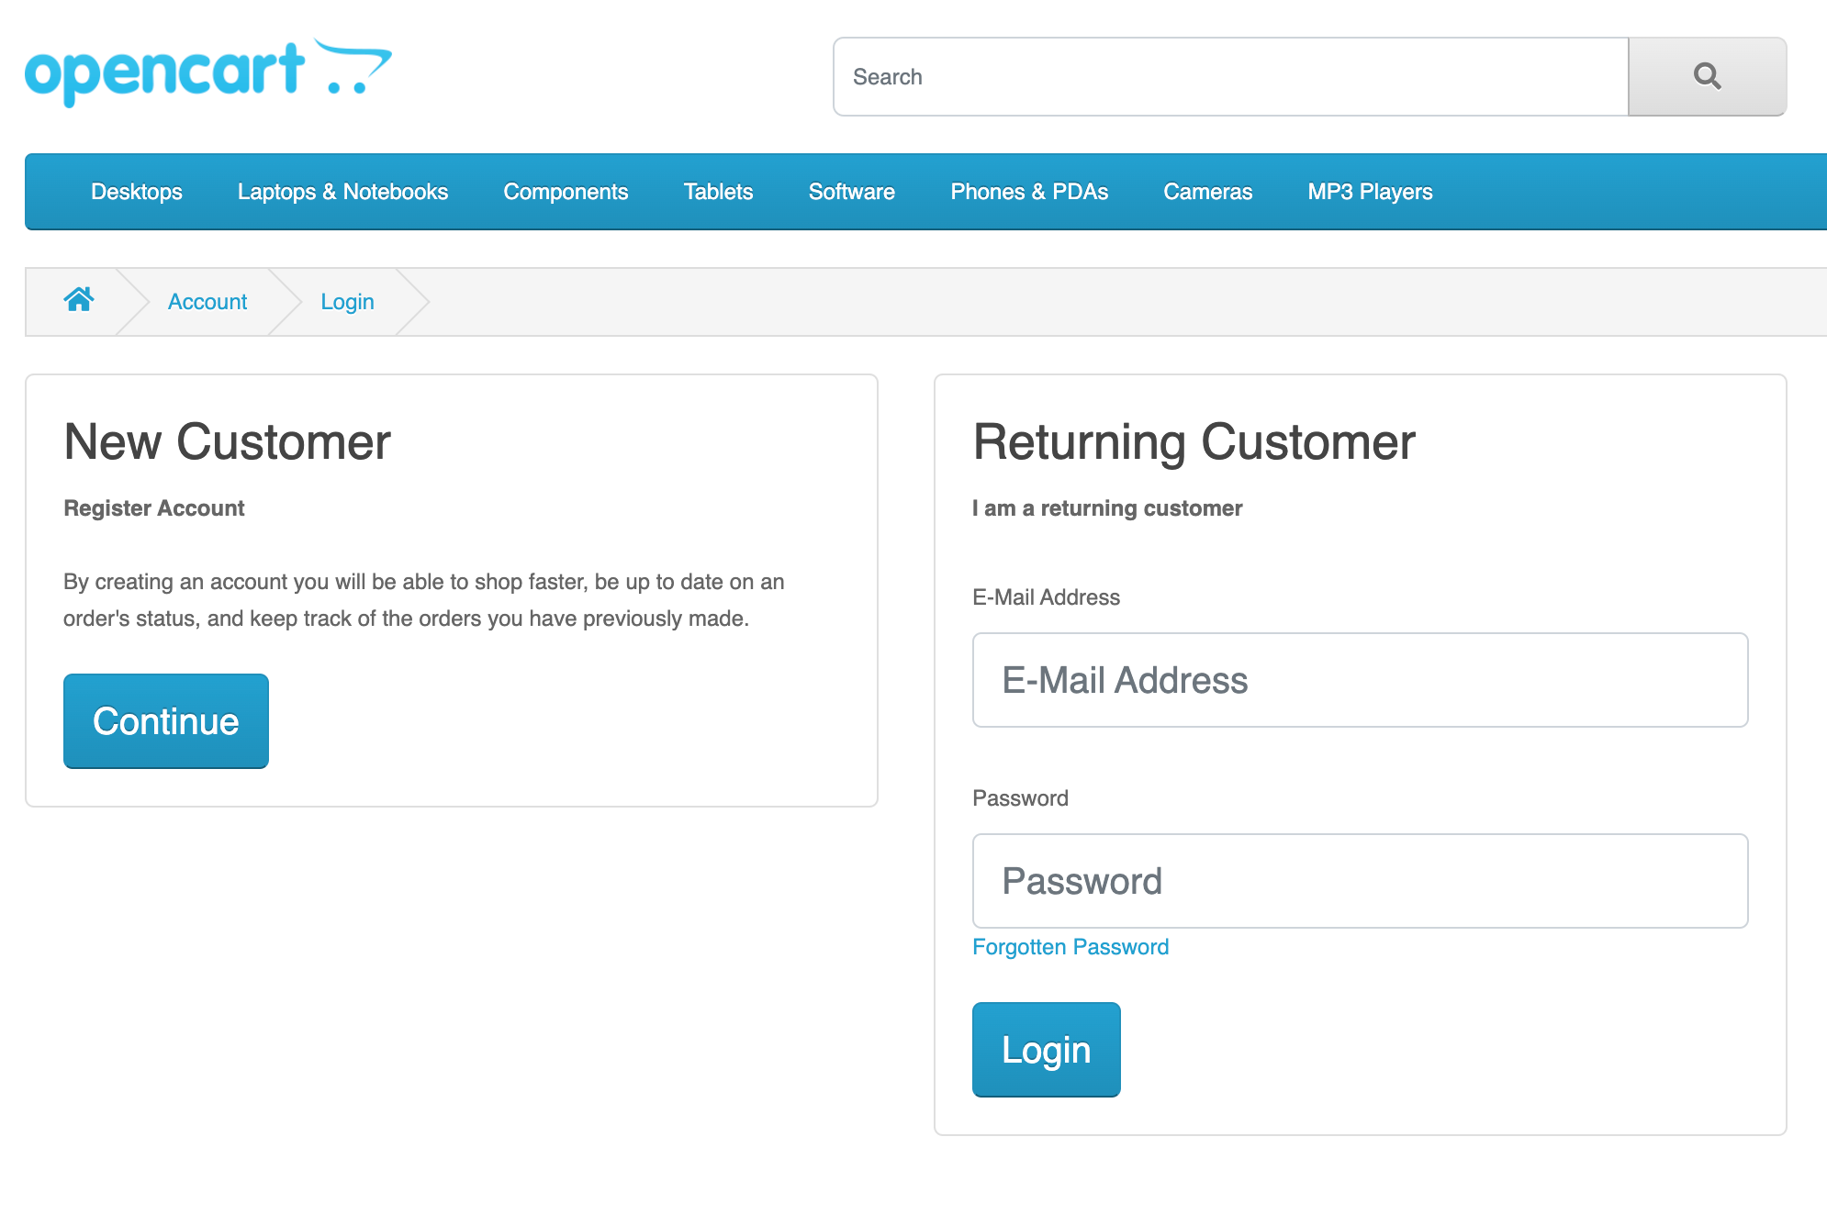

### **Registration**

**User Stories**

As a new user, I want to be able to easily create a new account and register for the platform.

As an existing user, I want to be able to update my account information and manage my preferences.

**Design Mockups**

Registration page design mockup

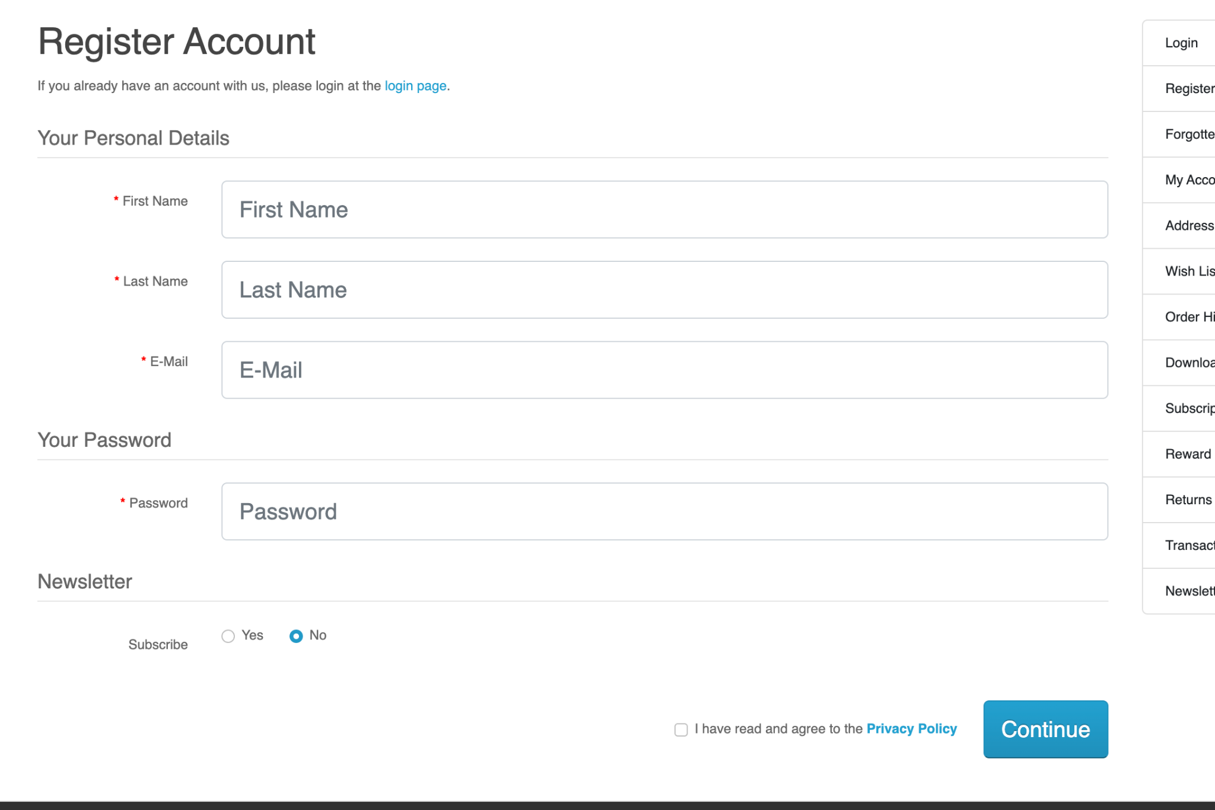

### **Add to Cart**

**User Stories**

As a customer, I want to be able to easily add products to my cart and view my cart.

As a customer, I want to be able to easily manage the contents of my cart.

**Design Mockups**

Product page design mockup with Add to Cart button

Cart page design mockup

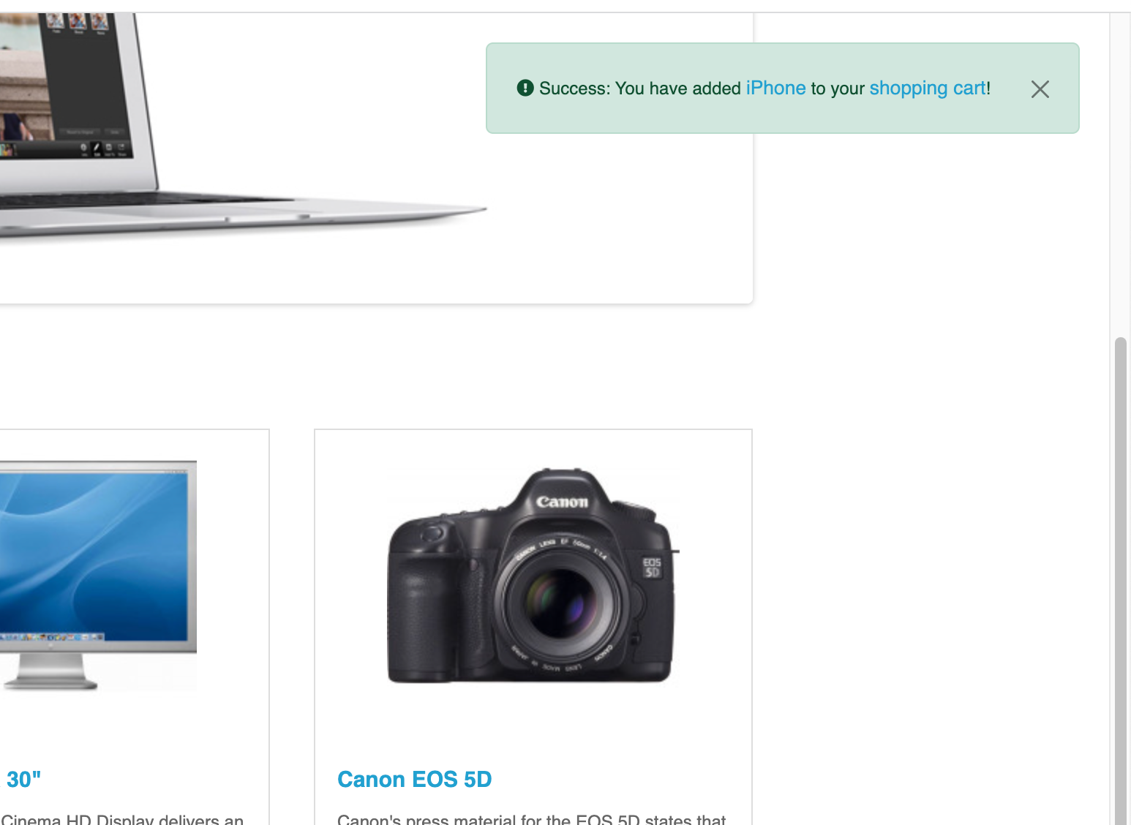

### **Checkout**

**User Stories**

As a customer, I want to be able to easily complete my purchase and provide my payment information.

As a customer, I want to be able to view my order summary and confirm my purchase.

**Design Mockups**

Checkout page design mockup

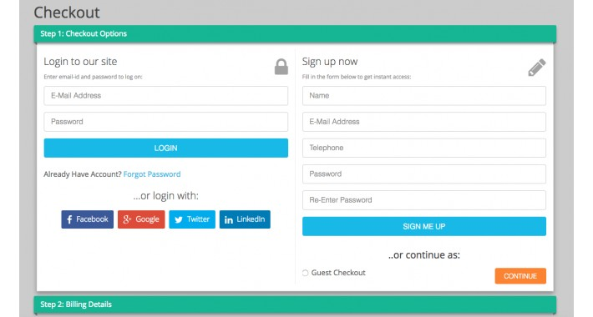

### **Payment Gateway**

**User Stories**

As a customer, I want to be able to choose from a variety of payment methods and securely enter my payment information.

As a platform, we want to ensure the security of customer payment information and provide a seamless payment experience.

**Design Mockups**

Payment Gateway page design mockup

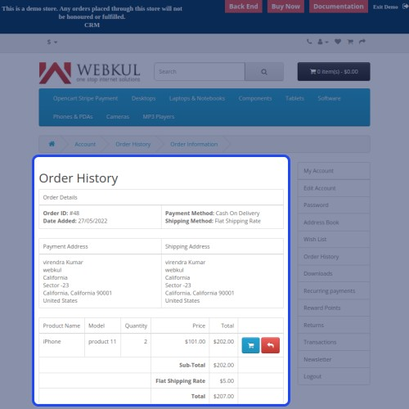

### **Orders**

**User Stories**

As a customer, I want to be able to view my order history and track the status of my orders.

As a platform, we want to be able to manage and fulfill customer orders efficiently.

**Design Mockups**

Orders page design mockup

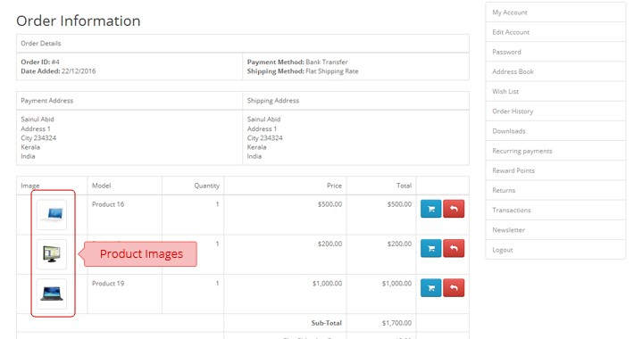

Functional testing has been done in this ecommerce web application. The required documents and tools that needed to do the testing are given below:

Requirement documentation:  
1. Test Plan  
2.Test Scenarios and Test Cases development  
3.Test Cases execution  
4.Requirment Traceability Matrix(RTM)  
5.Bug Report  
6.Test Report  
**Technical tools:**  
Website : <https://demo.opencart.com/index.php?route=common/home&language=en-gb>  
Project Management Tool : Click Up and Jira  
Bug Tracking Tool: Jira  
Platform: Google Docs, Google Sheets